KaiKo

Use-Case Specification

Version <1.0>

Revision History
Date | Version | Description | Author
15/05/2026 | 1.0 | Phiên bản đầu cho PA2: 8 đặc tả use-case (UC01–UC08). | KaiKo

Table of Contents
1. Use-case Model 4
2. Use-case Specifications 4
2.1 Use-case: Add a product to cart 4
2.2 Use-case: Create a new account 5

Use-case Model
[Use-case diagram below: actors (Quản trị viên, Player) and all use-cases with include/extend relationships]

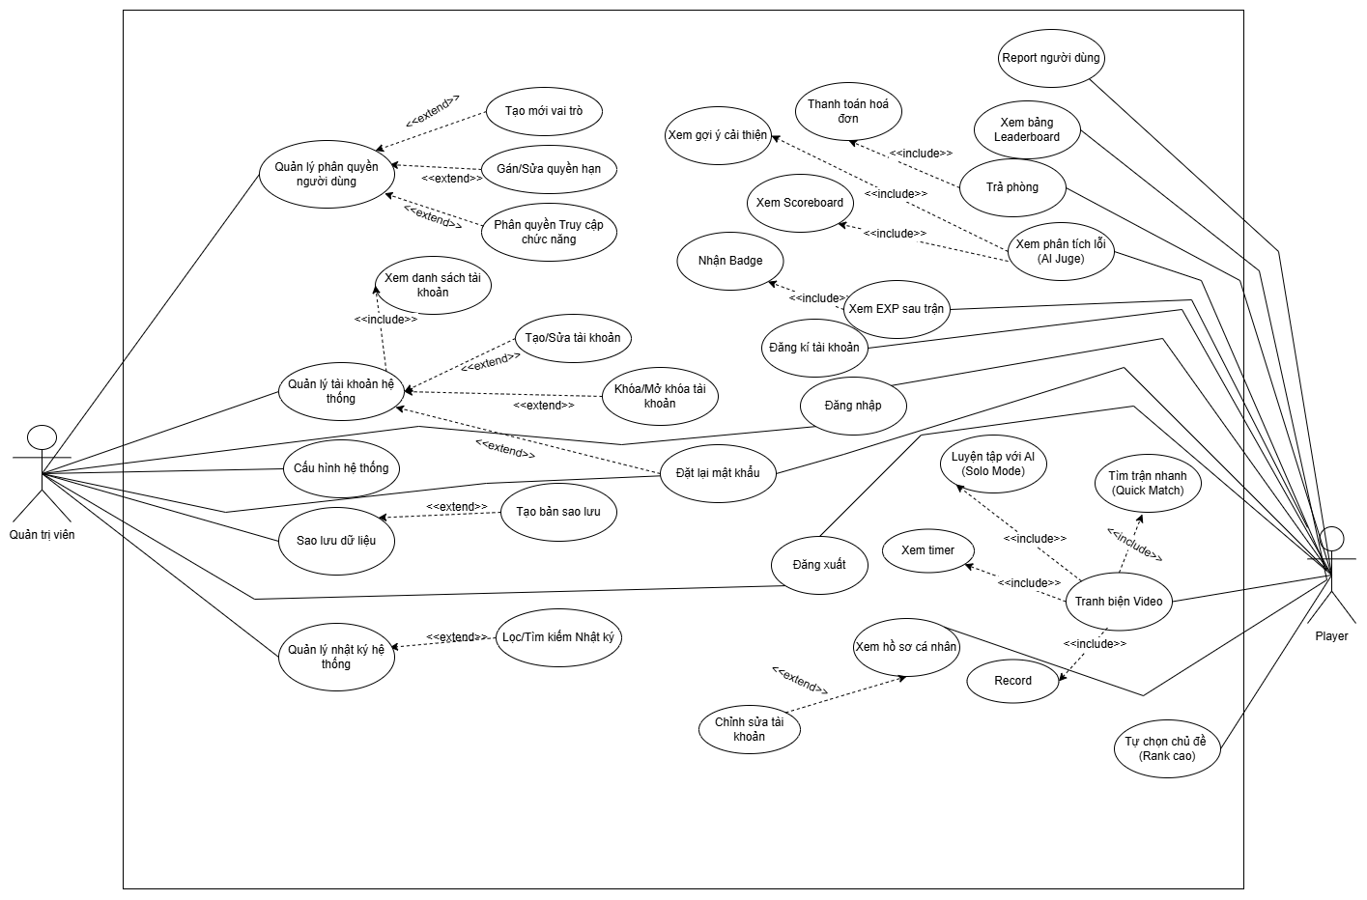
Figure 1 KaiKo Use-case Diagram

Use-case Specifications

Use-case: Login
Use case Name | Login
Brief description | Allows a Guest to authenticate using a username and password to access the KaiKo platform and all authorized features.
Actors | Guest (unauthenticated user)
Basic Flow | 1. The Guest navigates to the KaiKo homepage and clicks 'Đăng nhập'.  2. The System displays the login form (Username, Password).  3. The Guest enters credentials and clicks the login button.  4. The System sends POST /login with the credentials.  5. The System validates: retrieves the user from SQLite, hashes the provided password (SHA-256), and compares.  6. Credentials match: the System returns a success response with the username.  7. The System stores the username in localStorage and redirects the User to the Dashboard.
Alternative Flows | Alternative Flow 1: Invalid Credentials (from Step 5)  The username does not exist or the password hash does not match.  The System returns HTTP 401 and displays: 'Tên người dùng hoặc mật khẩu không đúng.'  The flow returns to Step 2.
Alternative Flow 2: Empty Fields (from Step 3)
The User submits with an empty username or password.
The System highlights the empty field and displays a validation message.
The flow returns to Step 3.
Alternative Flow 3: Server Unavailable (from Step 4)
POST /login times out or returns 5xx.
The System displays: 'Lỗi kết nối server. Vui lòng thử lại.'
The User may retry.
Pre-conditions | The Actor has a valid registered account.  The system is accessible via browser (Chrome ≥ 100 or Edge ≥ 100).
Post-conditions | The User is authenticated. Their username is stored in localStorage. They are redirected to the Dashboard.

Use-case: Register Account
Use case Name | Register Account
Brief Description | Allows a Guest to create a new KaiKo account by providing a username and password, enabling access to all authenticated features of the platform.
Actors | Guest (unauthenticated user)
Basic Flow | 1. The Guest clicks the 'Đăng ký' (Register) tab on the AuthPage.  2. The System displays the registration form (Username, Password).  3. The Guest fills in the fields and clicks 'Đăng ký'.  4. The System validates input: username not empty, password ≥ 6 characters.  5. The System sends POST /register to the backend.  6. The backend checks the username's uniqueness against existing accounts in SQLite.  7. The System hashes the password (SHA-256), creates the user record, and stores it in SQLite.  8. The System displays: 'Tạo tài khoản thành công!' and redirects to the Login screen.
Alternative Flows | Alternative Flow 1: Duplicate Username (from Step 6)  The username already exists in the database.  The backend returns HTTP 409.  The System displays: 'Tên người dùng đã tồn tại. Vui lòng chọn tên khác.'  The flow returns to Step 3.
Alternative Flow 2: Invalid Input (from Step 4)
Username is empty or password < 6 characters.
The System highlights the invalid field with a validation message.
The flow returns to Step 3.
Alternative Flow 3: Server Error (from Step 5)
POST /register returns 5xx or times out.
The System displays: 'Lỗi kết nối. Vui lòng thử lại.'
The User may retry.
Pre-conditions | The Actor is a Guest (not currently authenticated).  The system is accessible via browser.
Post-conditions | A new user record is created in SQLite with hashed password.  The Guest is redirected to the Login screen.

Use-case: Find-Match (Quick Match)
Use case Name | Find Match (Quick Match)
Brief Description | Allows an authenticated Player to enter the matchmaking queue and be automatically paired with another player of similar ELO rating to start a 1v1 video debate.
Actors | Player (authenticated user)
Basic Flow | 1. The Player navigates to ModeSelector and selects 'Tìm trận nhanh' (Quick Match).  2. The System connects to the backend via WebSocket (/ws/{client_id}).  3. The System sends: { type: 'find_match', player_name: username, mode: '1v1' }.  4. The backend ConnectionManager adds the Player to the matchmaking queue (ELO ±200 pairing).  5. A second Player with matching ELO is found: the backend creates a room and assigns a debate topic.  6. The backend sends { type: 'matched', room_id, opponent, topic } to both Players.  7. Both frontends receive 'matched' and redirect to DebateRoom with the assigned room_id and topic.  8. DebateRoom initializes WebRTC P2P connection via Firebase Realtime DB signaling.
Alternative Flows | Alternative Flow 1: No Opponent Found Within 30 Seconds (from Step 4)  The matchmaking timer expires with only one player in queue.  The backend notifies: 'Không tìm thấy đối thủ. Đang ghép ngẫu nhiên...'  The backend pairs with any available player regardless of ELO, or suggests Solo AI Mode.
Alternative Flow 2: WebSocket Connection Fails (from Step 2)
Connection to /ws/{client_id} fails.
The System displays: 'Không thể kết nối máy chủ. Vui lòng thử lại.'
The Player may click Retry.
Alternative Flow 3: Player Disconnects While Waiting (from Step 4)
The Player closes the browser while in queue.
The backend detects disconnection and removes the Player from the queue.
Pre-conditions | The Player is logged in. Username is in localStorage.  The browser supports WebRTC (Chrome ≥ 100 or Edge ≥ 100).
Post-conditions | Two Players are paired in a shared room. Both are redirected to DebateRoom with the same topic.

Use-case: Tranh biện Video (Video Debate)
Use case Name | Tranh biện Video (Video Debate)
Brief Description | Allows two matched Players to conduct a structured turn-based video debate in real time. The System manages the turn timer, captures speech via STT, detects fallacies with AI, and analyzes behavioral metrics throughout the match.
Actors | Player A (active speaker), Player B (active speaker)
Basic Flow | 1. DebateRoom loads: both players' video streams appear via WebRTC P2P connection.  2. The System displays the debate topic at the top of the screen.  3. Turn 1 starts: Player A is the active speaker (turn timer: 90 seconds).  4. Player A speaks. Web Speech API captures speech and displays real-time subtitles.  5. Each sentence from the transcript is sent to POST /analyze for AI fallacy detection.  6. MediaPipe FaceMesh continuously analyzes Player A's eye contact and facial expression.  7. Web Audio API monitors Player A's volume and pitch variance continuously.  8. The turn timer reaches 0 (or Player A ends the turn manually): the System saves Player A's transcript.  9. The System switches to Player B's turn. Steps 4–8 repeat for Player B.  10. After all turns (6–8 total) are completed, the System triggers the Scoreboard flow (UC06).
Alternative Flows | Alternative Flow 1: Fallacy Detected (from Step 5)  POST /analyze returns a fallacy label with confidence ≥ 70%.  The System shows a FallacyAlert popup: fallacy name (Vietnamese) + confidence %.  A score deduction is applied to the active speaker.  The alert auto-dismisses after 4 seconds without interrupting the video.
Alternative Flow 2: Player Disconnects Mid-Debate
WebSocket drops for one player.
The System notifies the remaining player: 'Đối thủ đã ngắt kết nối.'
The remaining player may view a partial scoreboard or return to Dashboard.
Alternative Flow 3: Camera/Microphone Permission Denied (from Step 1)
Browser does not grant camera/microphone access.
The System displays: 'Vui lòng cấp quyền truy cập camera và microphone.'
The User grants permission and refreshes.
Alternative Flow 4: Player Surrenders
The Player clicks 'Kết thúc tranh biện'.
The System marks the player as surrendered; opponent wins by default.
The System proceeds to Scoreboard (UC06).
Pre-conditions | Both Players have been matched (UC03 completed).  WebRTC connection is established. Camera and microphone permissions are granted.
Post-conditions | Debate is completed. Full transcripts and behavioral scores for both players are compiled.  The System proceeds to Scoreboard generation (UC06).

Use-case: Nhận cảnh báo ngụy biện (Receive Fallacy Alert)
Use case Name | Nhận cảnh báo ngụy biện (Receive Fallacy Alert)
Brief Description | Allows the System to notify the active speaker when a logical fallacy is detected in their spoken argument, displaying a non-intrusive popup alert and applying a score deduction.
Actors | Active Speaker (Player during their debate turn)
Basic Flow | 1. The Web Speech API returns a finalized transcript sentence during the active player's turn.  2. The frontend sends POST /analyze with { text: sentence, speaker: username }.  3. The backend runs XLM-RoBERTa inference on the sentence.  4. The model returns: { label: 'ad hominem', confidence: 0.82 }.  5. Confidence ≥ 70% and label is not 'fallacy of logic' (valid argument): the backend returns the fallacy result.  6. The frontend renders FallacyAlert: fallacy name in Vietnamese + confidence percentage as a floating overlay.  7. The System applies the score deduction to the active speaker's running score.  8. The fallacy is logged in the player's fallacy list for post-match analysis.  9. The alert auto-dismisses after 4 seconds without interrupting the video stream.
Alternative Flows | Alternative Flow 1: No Fallacy Detected (from Step 5)  Confidence < 70% or label is 'fallacy of logic' (valid argument).  Backend returns: { label: null }.  No alert is shown; no score deduction.
Alternative Flow 2: POST /analyze Times Out (from Step 3)
Backend takes > 3 seconds (model overloaded).
Frontend times out the request silently.
No alert for that sentence; debate continues normally.
Alternative Flow 3: Multiple Fallacies in Succession (from Step 6)
Multiple sentences return fallacies within 2 seconds.
Alerts are queued and shown one at a time, each for 4 seconds.
Pre-conditions | A debate match is active (UC04 in progress). It is the player's active speaking turn.  Web Speech API is running and generating transcript text.
Post-conditions | The player has been informed of the detected fallacy. Score deduction applied. Fallacy logged for post-match analysis.

Use-case: Xem Scoreboard và phân tích sau trận
Use case Name | Xem Scoreboard và phân tích sau trận
Brief Description | Allows both players to view their detailed post-match scores, strengths, weaknesses, and personalized improvement tips generated by the Gemini AI after a debate match ends.
Actors | Player A, Player B (both players after the match ends)
Basic Flow | 1. The final debate turn ends or a player surrenders.  2. The frontend compiles DebateResult: topic, transcripts, fallacy lists, video/audio behavioral scores.  3. The frontend sends POST /score with the DebateResult.  4. The backend preprocesses transcripts (filler word removal, TF-IDF compression if > 500 words).  5. The backend checks SemanticCache: cosine similarity ≥ 90% with cached transcript → return cached result.  6. Cache miss: backend calls Gemini 1.5 Flash API with compressed transcripts and rubric prompt.  7. Gemini returns structured JSON: scores for 4 criteria (logic 40pts, demeanor 20pts, voice 20pts, rebuttal 20pts), strengths, weaknesses, 3 tips per player.  8. Backend adds behavioral scores/deductions, returns final JSON to frontend.  9. Frontend renders Scoreboard: winner announcement, score breakdown, strengths/weaknesses, tips.  10. Frontend sends POST /save-match to store the result in SQLite match_history.
Alternative Flows | Alternative Flow 1: Gemini API Quota Exceeded (from Step 6)  Gemini returns HTTP 429.  Backend falls back to compute_local_scores() (rule-based from fallacy count + behavioral scores).  Scoreboard shown with notice: 'AI Judge không khả dụng – điểm tính tự động.'
Alternative Flow 2: Cache Hit (from Step 5)
SemanticCache finds result with cosine similarity ≥ 90%.
Backend returns cached result immediately (0 API calls).
Scoreboard displayed normally.
Alternative Flow 3: POST /save-match Fails (from Step 10)
Database write fails.
System logs the error but does not interrupt the Scoreboard view.
User is notified: 'Không thể lưu kết quả trận đấu.'
Pre-conditions | All debate turns are completed or a player has surrendered.  Full transcripts and behavioral scores for both players are compiled in memory.
Post-conditions | Both players can see their scores, strengths, weaknesses, and improvement tips.  Match result is saved in SQLite match_history (if /save-match succeeds).

Use-case: Luyện tập với AI (Solo Mode)
Use case Name | Luyện tập với AI (Solo Mode)
Brief Description | Allows an authenticated Player to practice debate skills by debating against an AI opponent (Gemini 1.5 Flash) in a solo session, without needing a real human opponent.
Actors | Player (authenticated user)
Basic Flow | 1. The Player navigates to ModeSelector and selects 'Luyện tập với AI'.  2. The System fetches a random topic via GET /random-topic.  3. DebateRoom loads in solo mode: Player's local video on left; AI avatar placeholder on right.  4. Turn 1 (Player's turn, 90 seconds): STT, fallacy detection, and behavioral analysis run as in UC04.  5. After the Player's turn ends, the frontend sends POST /generate-response with { topic, transcript_a: playerTranscript }.  6. Backend calls Gemini 1.5 Flash to generate an AI counter-argument in Vietnamese.  7. The AI response is displayed as text in the TranscriptPanel on the opponent side.  8. Turn 2 (Player's rebuttal). Steps 4–7 repeat for each subsequent turn.  9. After all turns, the System proceeds to Scoreboard (UC06) with opponent = 'AI'.
Alternative Flows | Alternative Flow 1: POST /generate-response Times Out (from Step 6)  Gemini does not respond within 5 seconds.  Backend returns fallback: 'AI không phản hồi được lúc này. Bạn tiếp tục nhé!'  Debate continues with the fallback text.
Alternative Flow 2: Random Topic Unavailable (from Step 2)
GET /random-topic fails.
Backend returns a topic from a hardcoded list of 20 preset topics.
Debate proceeds normally.
Alternative Flow 3: User Exits Mid-Session
The User closes the browser during the session.
Session ends without saving to match history.
Pre-conditions | The Player is logged in.  Browser supports WebRTC and Web Speech API (Chrome ≥ 100 or Edge ≥ 100).
Post-conditions | Solo session completed. System proceeds to Scoreboard (UC06) with opponent = 'AI'. Match saved to history if /save-match succeeds.

Use-case : Xem lịch sử trận đấu và ELO
Use case Name | Xem lịch sử trận đấu và ELO
Brief Description | Allows an authenticated Player to view their personal match history, ELO rating, cumulative statistics, and the weekly leaderboard on the Dashboard screen.
Actors | Player (authenticated user)
Basic Flow | 1. The Player navigates to the Dashboard page after logging in.  2. The frontend sends GET /history/{username} to retrieve the last 20 match records.  3. The backend queries SQLite match_history and returns records sorted by played_at (newest first).  4. The frontend sends GET /leaderboard to retrieve the top 10 users by wins and average score.  5. The Dashboard renders: personal statistics (total matches, wins, losses, avg score, ELO), match history table, leaderboard tab.  6. The Player scrolls the history table: each row shows date, opponent, topic, mode, result, scores.  7. The Player may switch to 'Bảng xếp hạng' (Leaderboard) tab to compare ranking with others.
Alternative Flows | Alternative Flow 1: No Match History (from Step 3)  Backend returns empty list.  Dashboard shows: 'Bạn chưa có trận đấu nào. Hãy bắt đầu tranh biện!'  A 'Tìm trận' button is prominently displayed.
Alternative Flow 2: GET /history Endpoint Fails (from Step 2)
Server returns error or times out.
System displays: 'Không thể tải lịch sử. Vui lòng thử lại.'
User may refresh to retry.
Alternative Flow 3: User Not Logged In (from Step 1)
localStorage has no username.
Frontend redirects to Login page (AuthPage).
Pre-conditions | The Player is logged in (username in localStorage).
Post-conditions | The Player can view their match history, ELO rank, personal statistics, and the leaderboard.

